**Style Guide**

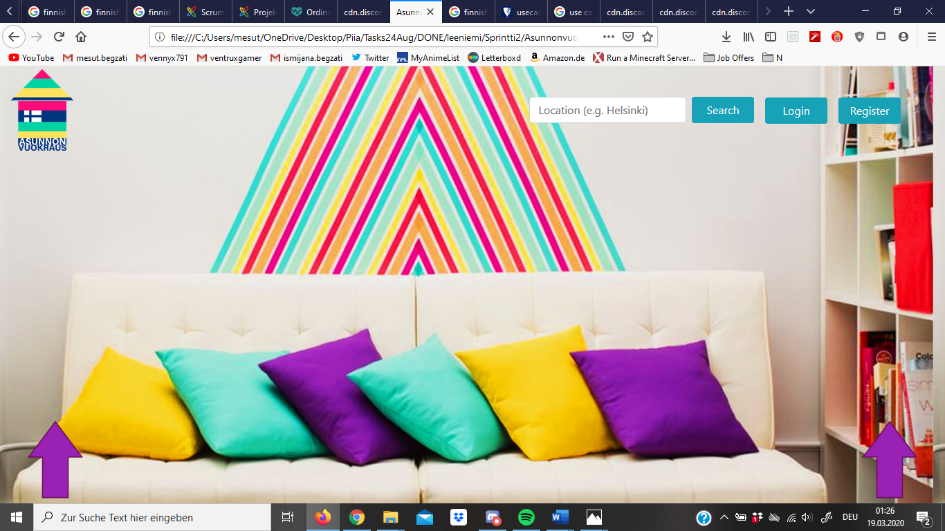

**Description**

I have chosen to go with a colorful website, the main color elements are blue and purple tones of color.

All the buttons have a hell blue color and when people hover over the purple arrow indicators a small bar shows up with more search and filtering options.

Even with all the colorful elements, I wanted to let the user feel modern and young, so at the frontpage, I left it pretty open.

The logo is also kept colorful and the house symbol features the Finnish flag, which shows immediately, for which country this website is for.

**Showing More Options**

